Sno-View Mobile Estates
36650 SE Tracy Rd
Estacada, Oregon

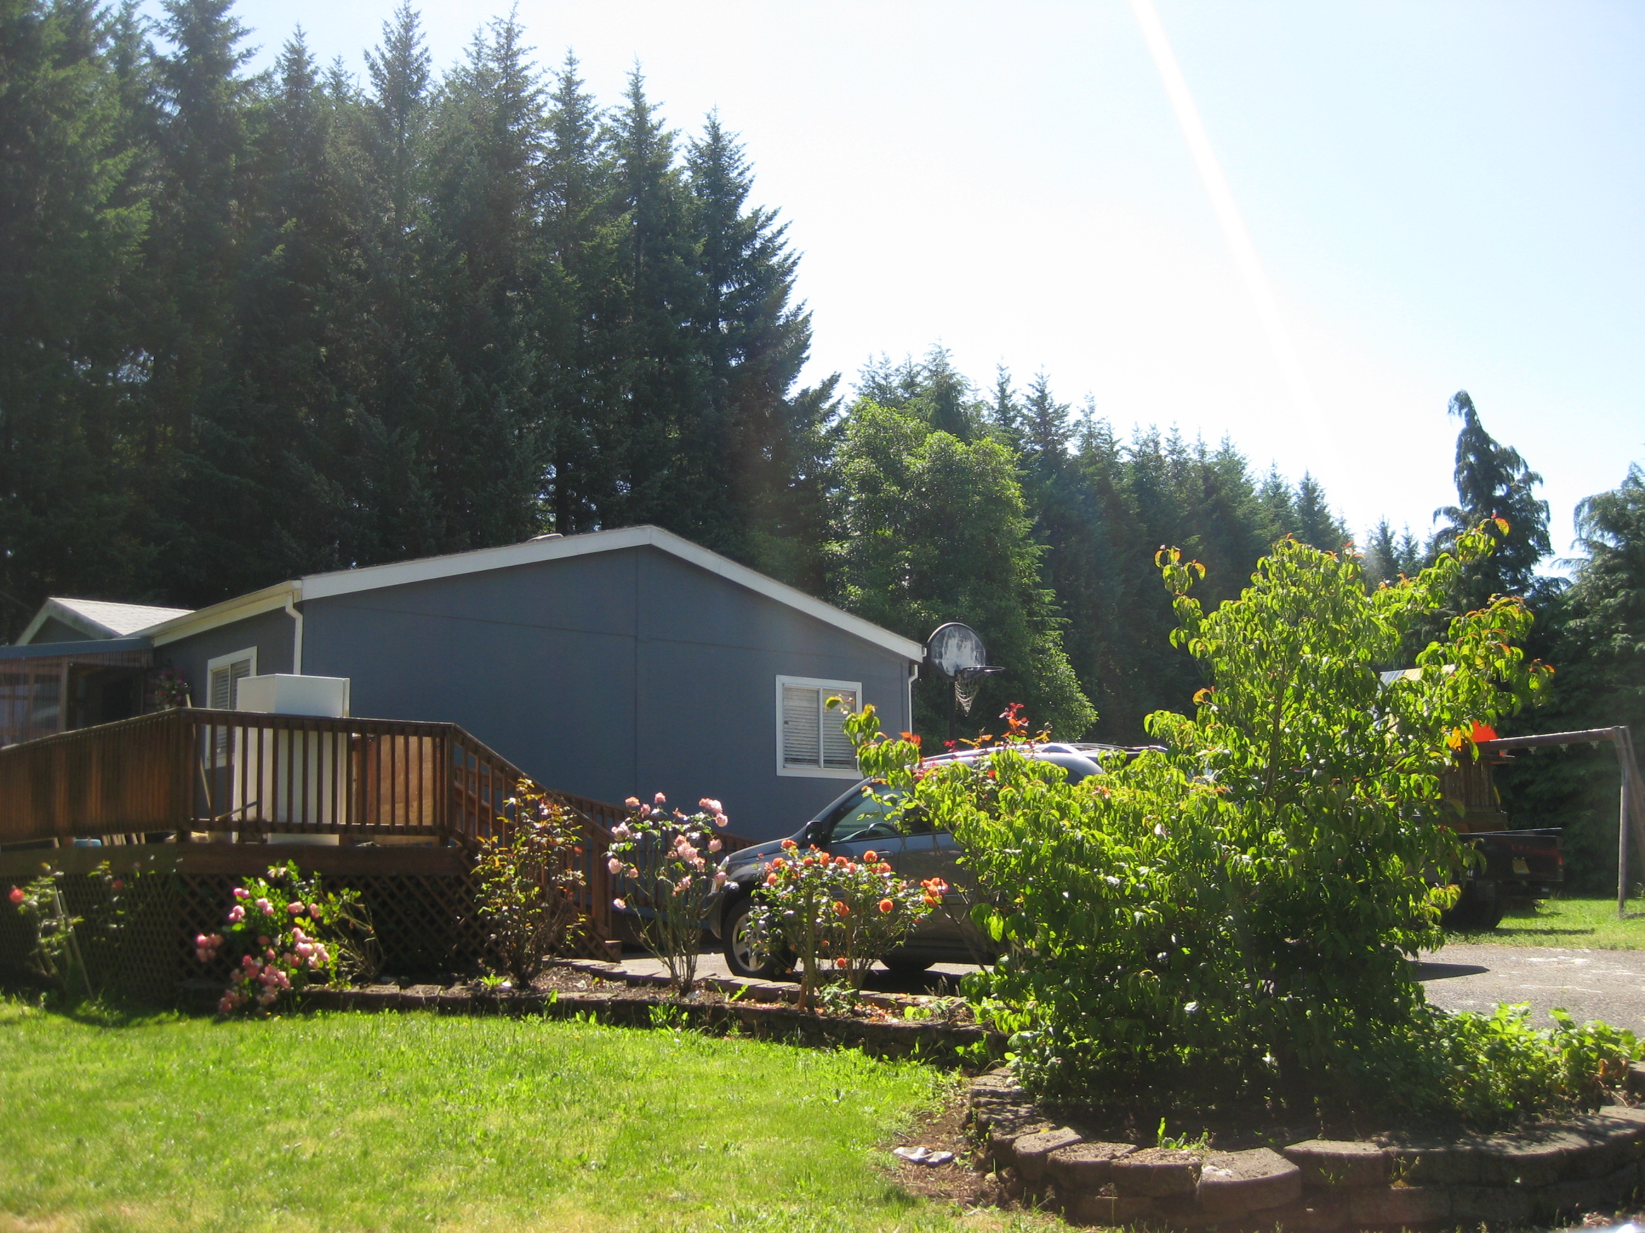

A 19-space, all-ages community located on a beautiful 19 acre parcel in Estacada

July 2014

For further information contact:
Loren Landau: 503-546-7662, llandau@cwbrokers.com
Brett Case: 503-546-7653, bcase@cwbrokers.com
Commonwealth Commercial Brokerage Company
18150 SW Boones Ferry Rd.
Portland, OR 97224
Fax: 503-768-4660
PROPERTY DESCRIPTION

General Description: Sno-View is a 19-space, all-ages mobile home park. It is located approximately 20 miles east of Clackamas and 25 miles south of Portland. Each lot sits on approximately 1 acre and provides a tranquil setting for tenants looking to enjoy a more peaceful environment. This asset has a unique allure due to the lot sizes, which lends itself to maintaining occupancy.

Age: Developed in 1970. This community has been owned and operated by the same family since it was developed.

Fair Housing Status: Sno-View is a HUD designated all-ages community.
Size: Approximately 19.92 acres.

Zoning: Property is zoned Rural Residential Farm and Forest. Sno View is a pre-existing, non-conforming use within this designation. This community was surveyed for 19 individual lots but the subdivision process was never completed.

Wetland/Flood Plain Status: This park is not in any known wetlands or floodplains.

Improvements:

- Interior Streets Interior streets are paved, approximately 25’ wide and are in good condition.

- Off-Street Parking Each space is provided a paved driveway which can accommodate multiple cars.

- Interior Lighting Overhead streetlights are located throughout the park.

Utility Systems:

- Water There are two separate wells servicing the park.

- Sewer There are individual septic tanks and drain fields for each of the spaces.

- Electricity Each space is individually metered with 200 amp service and billed directly to tenant by the service provider.

- Cable TV and Telephone These services are provided by local service providers and billed directly to the tenants.

- Garbage Individual can service is provided to the tenants and paid for by the park.

SW/DW Ratio: All of the homes are doublewides

Vacancies: There are no vacancies.

2013/2014 TAX INFORMATION:

Property ID | ACREAGE | REAL MARKET | ASSESSED VALUE | TAXES
01474559 | 19.92 | $809,611 | $422,798 | $5,453.54

